PRESS RELEASE 30th May 2016
World leader: Laying plough with 380 tonnes
Walter Foeckersperger is presenting the FSP 280 with double drawbar for a fantastic 380 tonnes of tear-out force at BAUMA 2016
To lay pipes with large diameters up to 630 mm reliably with the plough, even in very hard ground, very high tractive forces are required. Market and innovation leader Walter Foeckersperger is presenting the new FSP 280 laying plough with double drawbar, for a maximum tear-out force of 380 tonnes, for the first time at BAUMA 2016.
A laying plough system consists of a cable winch vehicle, which pulls the actual laying plough with a constant force. During the actual laying process, the laying unit on the plough blade displaces the ground at a depth of up to 2,5 meters, smooths the base of the slot and lays the cable or pipe safely in the created cavity in a single work step. In this way, one system can safely lay up to 10.000 meters in a single work day.
As cable plough technology has made a breakthrough in recent years as an efficient and reliable form of laying technology, with which the machines from market leader Walter Foeckersperger alone have laid 380.000 km of cables and pipes to date worldwide, the tasks are becoming increasingly challenging. Larger pipe diameters, up to 630 mm, very hard, in part rocky ground and work in permafrost, all require extremely high tractive forces.
Well equipped for all types of ground with 380 tonnes
With the strongest mobile cable winches in the world, which Walter Foeckersperger uses in its patented Schwenkmatic on its cable winch vehicles, combined with the new double drawbar on the large FSP 280 laying plough, presented at BAUMA 2016 for the first time, the system now achieves a maximum tear-out force of 360 tonnes via cable winch and a further 20 tonnes of driving force via the strong all-wheel drive of the laying plough. Thus, a total of 380 tonnes of tear-out force are available.
A Schwenkmatic cable winch pulls with a constant force of 90 tonnes. If the cable is relocated to the drawbar of the laying plough, and operated based on a pulley principle, the tractive force doubles to 180 tonnes. The new double drawbar of the large laying plough now enables two cable winch vehicles to pull the plough together with what is then 360 tonnes.

Walter Foeckersperger, the company
As a manufacturer of special machinery, Walter Foeckersperger GmbH develops innovative systems for trenchless laying of cables and pipes. With its high-performance laying systems, the medium-sized family company from Pauluszell, Bavaria is a top innovator and world market leader with over 55 years of experience in this field.
Today, FOECK cable plough systems are used by numerous customers on every continent, and are held in high regard. To date, the laying systems already sold by Walter Foeckersperger have laid more than 380,000 km of cables and pipes in the ground around the world.
The medium-sized family company was founded in 1931 and today it is run by the third generation of the family; by Dipl.-Ing. Walter Foeckersperger. In addition to the high level of technological expertise, Walter Foeckersperger GmbH is characterised by both a desire and commitment to produce outstanding technology for people and to protect the environment.

Manufacturer press contact: | Agency press contact:
Walter Foeckersperger GmbH | InVIA Marketing GmbH
Bernhard Foeckersperger | Michael Himmelstoss
Tel. +49(0)8742 919190 | Tel. +49 (0)89 38 99 99 29
bernhard.foeckersperger@foeck.com | michael.himmelstoss@invia-marketing.de
www.foeck.com | www.invia-marketing.de

Images:
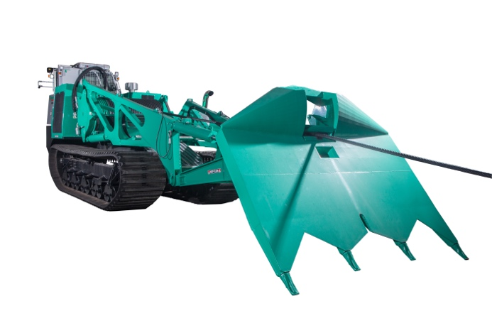
The FOECK Crawler with patented Schwenkmatic winch conctruction
pulls the FOECK Plough with a constant force of up to 90 tonnes (in the pulley)

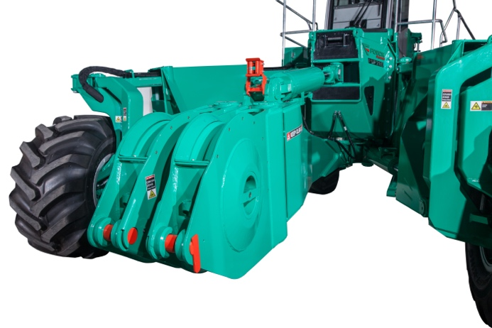
With the double drawbar, the FSP 280 laying plough can be
pulled in parallel by two winch vehicles with up to 360 tonnes (2x pulley)

Walter Foeckersperger and the new
FSP 280 laying plough with double drawbar

The FOECK laying system, consisting of the FOECK Crawler and the FOECK Plough
You can download images and text:
https://www.foeck.com/en/info/press-report/world-leaders-plough-with-380-tonnes/

