PRESS RELEASE 30th May 2016

World first: remote control system for
FOECK laying plough
Walter Foeckersperger increases the efficiency of its innovative cable and pipe laying systems with a new remote control system
When it comes to laying cables and pipes underground, the advanced laying plough system from Walter Foeckersperger is unrivalled in terms of efficiency: 20x quicker than excavating and 5x quicker than using a trencher. Now the innovative special machinery manufacturer has rounded off its systems with a remote control system, which enables the vehicle driver to safely control the powerful laying plough, even from outside the vehicle.
The FOECK laying system, consisting of a powerful winch vehicle – the FOECK Crawler or FOECK Truck – and the actual laying plough – the FOECK Plough – is currently the most efficient construction machine for safely laying cables and pipes with a diameter up to 630 mm in the ground in a single work step. Laying depths down to 2,5 meters and a daily laying capacity of up to 10.000 meters can be reliably achieved.
The FOECK laying system is also efficient in terms of operating personnel: the entire system can generally be operated by two people, the driver of the winch vehicle and the driver of the actual laying plough. To ensure that the driver of the laying plough can always keep a good overview in difficult terrain – slopes, forests, next to structures, etc. – a new option will be available as of BAUMA 2016: the FRC 1-X, an advanced remote control system for the FOECK laying plough.
With the FRC 1-X, all the functions of the laying plough can now be reliably operated in a radius of 30 meters around the vehicle; including the all-wheel drive of the plough machine, so it can be brought into the right position. As there is no need to appoint a third person for marshalling the laying vehicle, which is over 12 meters long and weighs 25 tonnes, the efficiency of the system is increased even further, as emphasized by Walter Foeckersperger: "With the FRC 1-X, a remote control system is now available which enables the vehicle driver to safely control the cable plough from any location in the vicinity of the laying system."
Walter Foeckersperger, the company
As a manufacturer of special machinery, Walter Foeckersperger GmbH develops innovative systems for trenchless laying of cables and pipes. With its high-performance laying systems, the medium-sized family company from Pauluszell, Bavaria is a top innovator and world market leader with over 55 years of experience in this field.
Today, FOECK cable plough systems are used by numerous customers on every continent, and are held in high regard. To date, the laying systems already sold by Walter Foeckersperger have laid more than 380.000 km of cables and pipes in the ground around the world.
The medium-sized family company was founded in 1931 and today it is run by the third generation of the family; by Dipl.-Ing. Walter Foeckersperger. In addition to the high level of technological expertise, Walter Foeckersperger GmbH is characterised by both a desire and commitment to produce outstanding technology for people and to protect the environment.

Manufacturer press contact: | Agency press contact:
Walter Foeckersperger GmbH | InVIA Marketing GmbH
Bernhard Foeckersperger | Michael Himmelstoss
Tel. +49(0)8742 919190 | Tel. +49 (0)89 38 99 99 29
bernhard.foeckersperger@foeck.com | michael.himmelstoss@invia-marketing.de
www.foeck.com | www.invia-marketing.de

Images:
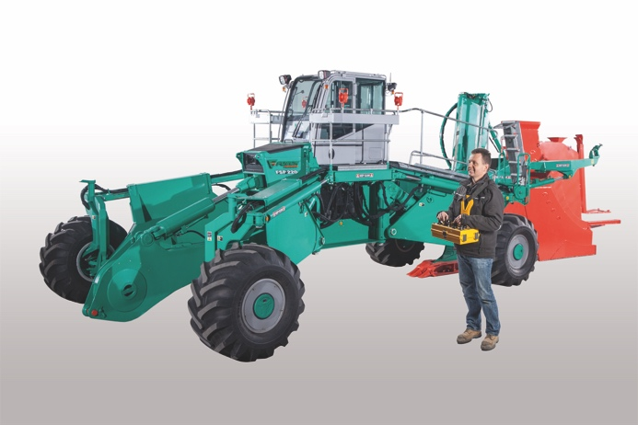
With the new remote control system, the FOECK laying plough
can now also be fully operated from outside the vehicle

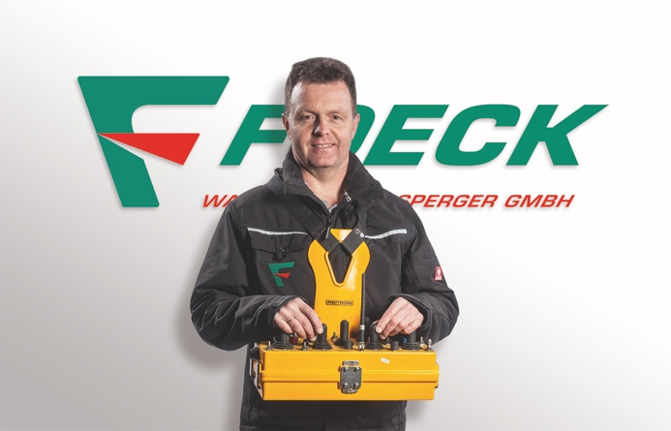
Walter Foeckersperger with the company's latest innovation:
the FRC 1-X, a remote control system for the laying plough

You can download images and text:
https://www.foeck.com/en/info/press-report/worlds-first-remote-control-for-foeck-plough/

